5th Grade /Module 5-Lesson 13/Mrs. Faour

Objective: Multiply mixed number factors, and relate to the distributive property and the area model.

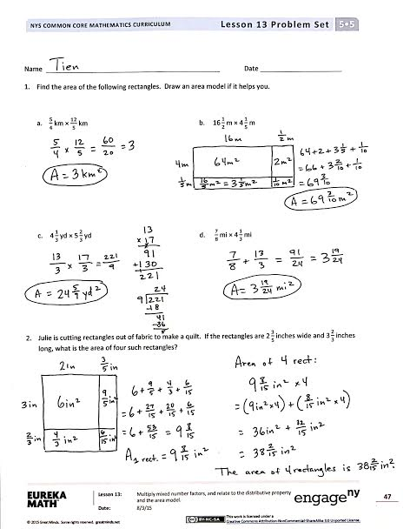Problem –Set page/Watch Video

Fluency Practice /Watch Video

Application Problem/Watch Video

Lesson Requirements:

* Class Note/use your math notebook
* Homework page/Submit
* Exit Ticket page/Submit

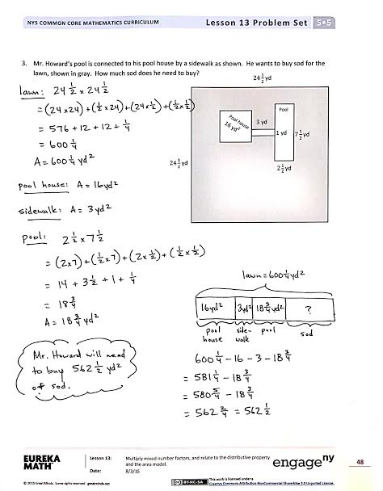

Name Date

1. Find the area of the following rectangles. Draw an area model if it helps you.

|  |  |
| --- | --- |
| 1. km ×km | 1. m × m |
| 1. yd × yd | 1. mi × mi |

1. Julie is cutting rectangles out of fabric to make a quilt. If the rectangles are $\text{2}\frac{3}{5}$ inches wide and $\text{3}\frac{2}{3}$ inches long, what is the area of four such rectangles?
2. Mr. Howard’s pool is connected to his pool house by a sidewalk as shown. He wants to buy sod for the lawn, shown in gray. How much sod does he need to buy?

3 yd

1 yd

$2\frac{1}{2}$ yd

$7\frac{1}{2}$ yd

Pool

Pool house 16 yd2

yd

yd

Name Date

Find the area of the following rectangles. Draw an area model if it helps you. (optional)

1. $\frac{7}{2}$ mm × $\frac{14}{5}$ mm 2. $\text{5}\frac{7}{8}$ km × $\frac{18}{4}$ km

Name Date

1. Find the area of the following rectangles. Draw an area model if it helps you.(optional)

|  |  |
| --- | --- |
| 1. cm × cm | 1. ft × ft |
| 1. in × in | 1. m × m |

1. Chris is making a tabletop from some leftover tiles. He has 9 tiles that measure $\text{3}\frac{1}{8}$ inches long and $\text{2}\frac{3}{4}$ inches wide. What is the greatest area he can cover with these tiles?
2. A hotel is recarpeting a section of the lobby. Carpet covers the part of the floor as shown below in gray. How many square feet of carpeting will be needed?

$\text{19}\frac{1}{2}$ ft

$\text{13}\frac{3}{5}$ ft

$\text{11}\frac{3}{4}$ ft

$\text{3}\frac{3}{4}$ ft

12 ft

17 ft

$2\frac{1}{2}$ ft

$\text{31}\frac{7}{8}$ ft